CSC-204 IS Lab
Project Report


Zero Trust Vault

Submitted By:
- 2024-CS-702
- 2024-CS-711
- 2024-CS-717

Submitted To:
Mam.Sonia
Dated: 9th June 2026

Department of Computer Science
University of Engineering and Technology Lahore, New Campus
Table of Contents
1. Abstract 4
2. Introduction 5
2.1 Project Overview 5
2.2 Purpose 5
2.3 Objectives 5
2.4 Scope 6
2.5 Significance 6
3. Problem statement 7
4. Background 8
4.1 The CIA Triad 8
4.2 Symmetric Key Cryptography (AES-256) 9
4.3 Cryptographic Hashing (SHA-256) 9
4.4 Authentication and Password Security 10
4.5 Access Control Using JSON Web Tokens (JWT) 10
5. Methodology 10
5.1 Software Development Approach 10
5.2 System Architecture 11
5.3 File Upload and Encryption Workflow 12
5.4 File Download and Decryption Workflow 13
5.5 Database Design 14
5.6 Cryptographic Operations 15
6. Tools and environment 15
7. Implementation screenshots/results 16
7.1 Screen 1: Landing and Architecture Page 17
7.2 Screen 2: User Registration Interface 18
7.3 Screen 3: User Login Interface 19
7.4 Screen 4: Main User Dashboard 20
7.5 Screen 5: File Upload and Encryption Process 21
7.6 Screen 6: File Download and Decryption Process 22
7.7 Screen 7: Integrity Verification and Tamper Detection 23
8. Testing and evaluation 24
8.1 Security and Functional Test Cases 24
8.2 Performance and Resource Evaluation 26
8.3 Requirements Validation 26
9. Security recommendations 27
9.1 Enterprise Key Management Service (KMS) 27
9.2 Multi-Factor Authentication (MFA) 27
9.3 API Rate Limiting and Intrusion Detection 27
9.4 Immutable Audit Logging 28
10. Ethical and legal considerations 28
10.1 User Privacy and Data Protection (GDPR / CCPA) 28
10.2 10.2 Responsible Data Handling 28
11. Limitations 29
11.1 Process Spawning Overhead 29
11.2 MongoDB Document Size Limit 29
11.3 Lack of Distributed Storage 29
11.4 Single Encryption Key Risk 29
12. Conclusion 29
12.1 Objectives Achieved 29
12.2 Lessons Learned 30
12.3 Future Enhancements 30
13. References 30

Abstract
Zero-Trust Vault is a secure file storage system developed to protect user data from unauthorized access, tampering, and database breaches. Traditional cloud storage solutions often rely on trusting the storage layer, which can expose sensitive files if the database is compromised. To address this issue, the proposed system adopts a zero-trust approach by encrypting files before storage and verifying their integrity during retrieval. The application is built using the MERN stack and integrates OpenSSL-based cryptographic operations. Uploaded files are encrypted using AES-256 encryption, while SHA-256 hashing is used to generate integrity signatures. User authentication is secured through encrypted credential storage and access control mechanisms. To improve reliability, the system maintains redundant file records and performs integrity verification before file access. If file corruption or unauthorized modification is detected, the system prevents access to the affected file and restores a valid copy from a secure backup repository. The implementation was evaluated through functional and security testing, demonstrating successful encryption, integrity verification, tamper detection, and file recovery capabilities. The results show that Zero-Trust Vault provides a secure and practical solution for protecting sensitive digital assets in environments where the storage infrastructure cannot be fully trusted.

Introduction

Project Overview
The Zero-Trust Vault is a secure web application designed to provide protected file storage through the use of modern cryptographic techniques. In contemporary computing environments, organizations depend on databases to store and manage sensitive digital information. However, storing files without encryption or relying solely on application-level protections can expose systems to unauthorized access, data breaches, and malicious modifications. The Zero-Trust Vault adopts a zero-trust approach in which the database is treated as an untrusted storage layer. Built using the MERN stack (MongoDB, Express.js, React.js, and Node.js) and integrated with OpenSSL-based cryptographic operations, the system encrypts files before storage and verifies their integrity whenever they are accessed.

Purpose
The primary purpose of the Zero-Trust Vault is to protect stored files from unauthorized access and tampering, even when an attacker gains direct access to the database contents. Traditional cloud storage systems often assume that the storage infrastructure itself is trustworthy. In contrast, this project ensures that sensitive files remain encrypted within the database and can only be accessed through authorized cryptographic processes. By combining encryption, integrity verification, and secure authentication, the system provides stronger protection against both external attacks and insider threats.

Objectives
The project was developed with the following objectives:
- Secure Authentication: Implement a secure authentication mechanism salted password hashing.
- Cryptographic Confidentiality: Encrypt all uploaded files before storing them in the database.
- Minimized Plaintext Exposure: Reduce the presence of unencrypted file data on the server during processing and storage operations.
- Integrity Verification: Generate and verify cryptographic hashes to detect unauthorized file modifications.
- Backup and Recovery: Maintain secure backup copies and provide recovery mechanisms for corrupted or altered files.
- Access Control: Ensure that only authenticated users can upload, download.

Scope
The scope of this project includes:
- User registration and login functionality.
- Secure file upload and download operations.
- AES-256 file encryption and decryption.
- SHA-256 hash generation and integrity verification.
- Secure storage of encrypted files within MongoDB.
- Backup and recovery functionality for damaged or modified files.
- A web-based dashboard for file management and monitoring.
The following features are outside the scope of this project:
- Multi-user file sharing.
- End-to-end collaborative editing.
- Advanced metadata obfuscation.
- Distributed cloud storage across multiple servers.
- Support for very large files beyond the intended storage limits of the prototype implementation.

Significance
This project demonstrates the practical application of cryptographic security principles in modern web development. It provides a real-world implementation of encryption, hashing, authentication, and integrity verification techniques within a complete software system. The project also serves as an educational example of how security controls can be integrated into storage applications to protect sensitive data. By treating the database as an untrusted component, the system illustrates the concept of defense-in-depth and highlights the importance of securing data beyond traditional access-control mechanisms.

Problem statement
Modern organizations increasingly depend on cloud platforms and database-driven systems to store sensitive digital information. In many traditional storage architectures, the database or storage infrastructure is assumed to be trustworthy. Files are often stored either in plaintext or through storage-level encryption mechanisms that rely on the same system responsible for managing the data. As a result, users must trust database administrators, server operators, and the storage environment itself to protect confidential information.
This approach introduces significant security risks. If an attacker gains unauthorized access to the database, storage server, or backup repositories, sensitive files may be exposed. Even when encryption is employed at the storage layer, the encryption keys are frequently managed by the same infrastructure, reducing the effectiveness of the protection against privileged insiders or system compromise.
Another major concern is the lack of effective integrity verification. Traditional storage systems may not verify whether a file has been modified after it was uploaded. Unauthorized alterations, accidental corruption, or malicious tampering can remain undetected until the file is accessed by a user. Without cryptographic verification mechanisms, organizations cannot reliably determine whether stored data remains unchanged and authentic.
Addressing these challenges is essential because modern organizations store highly sensitive information, including financial records, business documents, intellectual property, and personal data. Protecting the confidentiality and integrity of these assets is critical for maintaining user trust, ensuring business continuity, and supporting compliance with data protection regulations. A secure storage solution should therefore assume that the storage layer may become compromised and should protect data independently of the underlying database infrastructure.
If these vulnerabilities remain unaddressed, several serious consequences may occur. Unauthorized parties may gain access to confidential files, resulting in data breaches and privacy violations. Attackers may alter stored files without detection, potentially distributing malicious content or compromising the reliability of critical information. Furthermore, the absence of integrity verification mechanisms makes forensic investigations and audit processes more difficult, reducing an organization's ability to prove that stored information has remained authentic and unchanged over time.
Therefore, there is a need for a secure file storage system that protects data through strong encryption, verifies file integrity using cryptographic techniques, and minimizes reliance on the trustworthiness of the storage infrastructure. The proposed Zero-Trust Vault addresses these requirements by combining encryption, authentication, integrity verification, and recovery mechanisms to provide enhanced protection for sensitive digital assets.

Background
The security architecture of the Zero-Trust Vault is based on established information security principles and cryptographic techniques. These concepts provide the foundation for protecting stored files against unauthorized access, modification, and loss.

The CIA Triad
The CIA Triad consists of Confidentiality, Integrity, and Availability, which form the foundation of information security. Confidentiality ensures that sensitive information remains accessible only to authorized users. In the Zero-Trust Vault, confidentiality is achieved through AES-256 encryption, preventing unauthorized individuals from viewing stored file contents.
Integrity ensures that information remains accurate and unaltered throughout its lifecycle. Any unauthorized modification to stored files should be detectable. The system implements integrity verification using SHA-256 cryptographic hashing, allowing file authenticity to be validated whenever data is accessed.
Availability ensures that authorized users can access their information whenever required. To support availability, the system incorporates backup and recovery mechanisms that enable restoration of valid file copies in the event of corruption or accidental data loss.

Symmetric Key Cryptography (AES-256)
Encryption is the primary mechanism used to protect file confidentiality within the system. The Zero-Trust Vault utilizes the Advanced Encryption Standard (AES) with a 256-bit key length. AES is a symmetric encryption algorithm, meaning the same key is used for both encryption and decryption operations.
The implementation uses Cipher Block Chaining (CBC) mode, where each plaintext block is combined with the previous encrypted block before encryption. This approach prevents identical plaintext data from producing identical ciphertext patterns. CBC mode also requires a randomly generated Initialization Vector (IV), ensuring that the same file encrypted multiple times produces different ciphertext outputs.
To strengthen cryptographic keys, the system employs Password-Based Key Derivation Function 2 (PBKDF2). This mechanism combines a password with a random salt and multiple processing iterations to generate a stronger encryption key that is more resistant to brute-force and dictionary attacks.

Cryptographic Hashing (SHA-256)
A cryptographic hash function converts data of any size into a fixed-length output known as a digest. The Zero-Trust Vault uses SHA-256 to verify file integrity and detect unauthorized modifications.
A secure hash function should provide pre-image resistance, second pre-image resistance, and collision resistance. These properties make it computationally infeasible to reverse the original data, generate alternative inputs with the same hash, or find two different inputs that produce identical outputs.
SHA-256 also exhibits the avalanche effect, meaning that even a minor change in the original file results in a significantly different hash value. This characteristic makes cryptographic hashing highly effective for integrity verification.

Authentication and Password Security
Secure authentication is essential for restricting access to protected resources. Instead of storing passwords directly, the system stores salted password hashes. A unique random salt is generated for each user account before the password is processed through the hashing algorithm.
This approach ensures that users with identical passwords do not have identical stored hashes, making rainbow-table attacks significantly more difficult. By storing only password hashes rather than plaintext passwords, the risk of credential exposure is reduced even if the database is compromised.

Access Control Using JSON Web Tokens (JWT)
After successful authentication, the system uses JSON Web Tokens (JWT) to manage user sessions and authorize access to protected resources. A JWT consists of a header, payload, and cryptographic signature.
The signature is generated using a secret key known only to the server. Whenever a request is received, the server validates the token before granting access to protected resources. Any attempt to modify the token contents invalidates the signature and causes verification to fail.
Because JWT authentication is stateless, the server does not need to maintain session information for each user. This improves scalability while ensuring that only authenticated users can access their encrypted files and account resources.

Methodology
The methodology describes the planning, design, architecture, and implementation approach used to develop the Zero-Trust Vault. The project was designed with a strong focus on security, ensuring that confidentiality, integrity, and controlled access were incorporated throughout the system development process.

Software Development Approach
The Zero-Trust Vault was developed using the Agile Prototyping Model. This iterative methodology was selected because it supports rapid development cycles, continuous testing, and incremental security improvements. The development process began with identifying major security threats, including unauthorized database access, file tampering, and credential compromise. Appropriate cryptographic technologies such as AES-256 encryption and SHA-256 hashing were then selected to address these threats.
The system architecture was designed to separate the client interface, application logic, cryptographic operations, and database storage. Development proceeded incrementally, beginning with user authentication, followed by secure file upload and encryption, and finally integrity verification and recovery functionality. Throughout the implementation phase, security testing was conducted to validate system behavior under various attack scenarios.

System Architecture
The application follows a multi-layered client-server architecture based on the MERN stack. The React frontend provides the user interface and communicates with the backend through RESTful API requests secured using JSON Web Tokens (JWT). The Node.js and Express server functions as the central processing layer responsible for authentication, encryption, decryption, integrity verification, and file management operations.
OpenSSL is integrated as a dedicated cryptographic engine to perform encryption, decryption, key derivation, and hashing operations. MongoDB serves as the persistent storage layer and maintains user records, encrypted file data, and backup copies. This architecture ensures that cryptographic operations are isolated from the database layer and that sensitive files remain encrypted while stored.
The React client never directly accesses encryption keys, and MongoDB stores only encrypted file content rather than plaintext data. The server acts as an intermediary processing layer that performs cryptographic operations before data is written to or retrieved from storage.
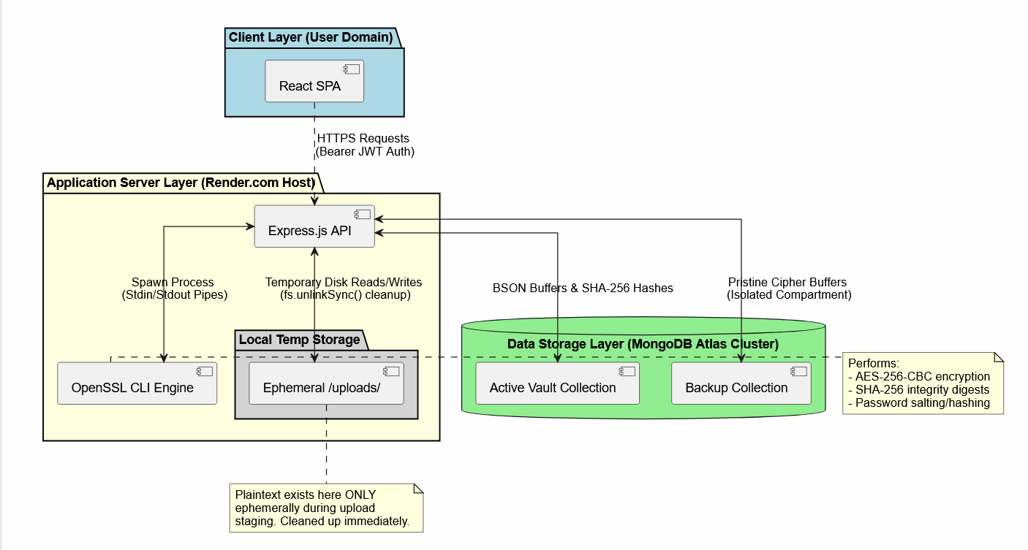

File Upload and Encryption Workflow
When a user uploads a file, the server temporarily stages the file for processing. The uploaded file is passed to OpenSSL, which performs AES-256-CBC encryption using a secure key derived through PBKDF2. Once encryption is complete, a SHA-256 hash is generated to create a unique integrity signature for the encrypted file.The encrypted file is then loaded into memory and stored within the SecureFiles collection. A backup copy is simultaneously stored in the BackupFiles collection to support future recovery operations. After successful storage, all temporary processing files are removed from the server. This process ensures that only encrypted file content remains permanently stored in the database.
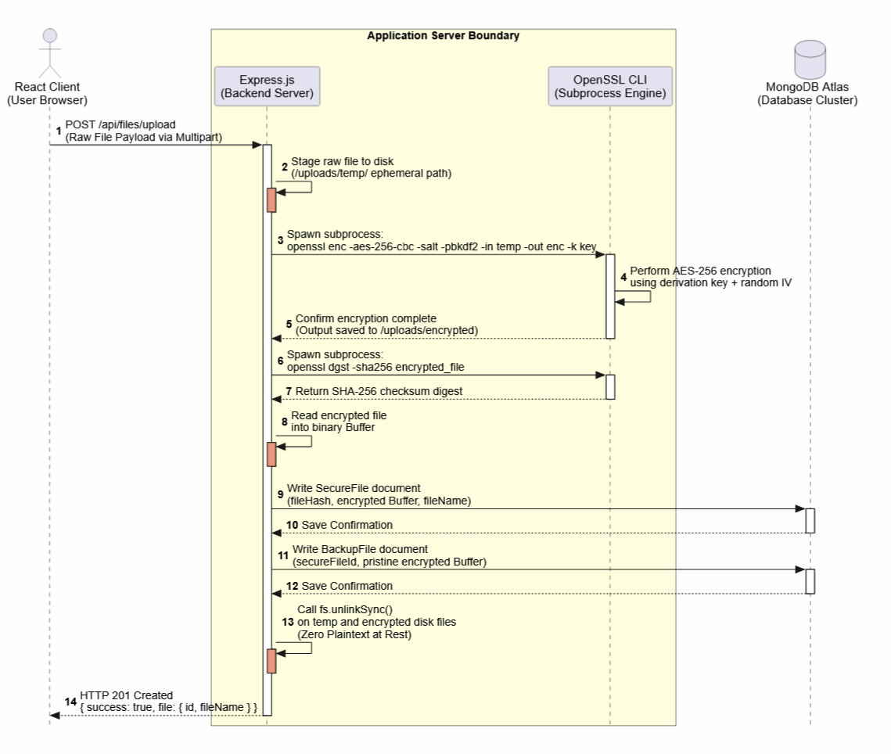

File Download and Decryption Workflow
When an authenticated user requests a file, the server retrieves the encrypted file and associated metadata from MongoDB. Before decryption occurs, the system recalculates the SHA-256 hash and compares it with the stored hash value to verify file integrity.
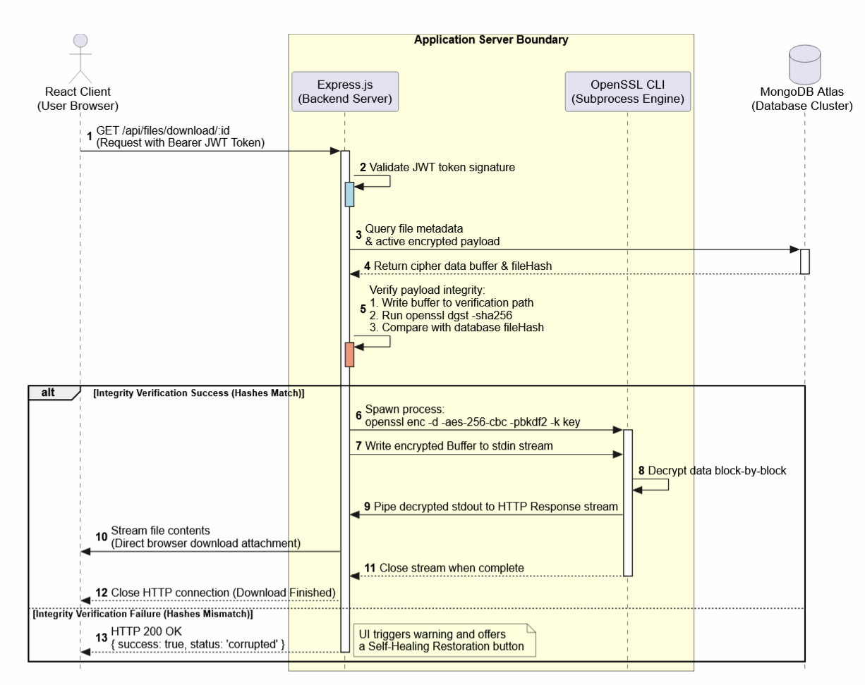
If integrity verification succeeds, the encrypted file data is passed to an OpenSSL decryption process. The decrypted content is streamed directly to the client through the HTTP response without being permanently stored on the server. If integrity verification fails, the system blocks access and may initiate recovery procedures using the backup copy.

Database Design
The database consists of three primary collections: Users, SecureFiles, and BackupFiles.
- The Users collection stores account information including usernames, email addresses, password hashes, and optional profile information. Passwords are stored as salted cryptographic hashes rather than plaintext values.
- The SecureFiles collection stores encrypted file content together with metadata such as file names, file sizes, upload timestamps, ownership information, and integrity hashes. Since only encrypted file data is stored, unauthorized database access does not directly reveal file contents.
- The BackupFiles collection maintains backup copies of encrypted files. These backups provide an additional layer of protection by enabling file restoration when corruption or unauthorized modification is detected.

Cryptographic Operations
The security of the Zero-Trust Vault relies on a combination of encryption, hashing, and authentication mechanisms. AES-256-CBC is used to encrypt uploaded files before storage, ensuring confidentiality of user data. PBKDF2 is employed to strengthen cryptographic key generation and increase resistance against brute-force attacks.
SHA-256 hashing is used to generate integrity signatures for encrypted files. These signatures are verified whenever files are accessed, allowing the system to detect corruption or unauthorized modifications.
Together, these cryptographic mechanisms provide multiple layers of protection and support the overall zero-trust design philosophy of the application.

Tools and environment
Category | Technology | Purpose in the System
Frontend | React 18 | Development of the Interfaces.
 | Vite | Frontend build tool and development server.
 | Tailwind CSS | Responsive UI design and styling framework.
 | Axios | Communication with backend REST APIs
 | Lucide React | Icon library
Backend | Node.js | Runtime environment for server-side application logic.
 | Express.js | REST API development and request handling.
 | Multer | Processing and temporary storage of uploaded files.
 | JSON Web Token (JWT) | Authentication and authorization of users.
 | Dotenv | For environment variables and application secrets.
 | CORS | Control of cross-origin resource sharing policies.
Cryptography | OpenSSL CLI | File encryption, decryption, key derivation, and SHA-256 hash generation.
Database | MongoDB Atlas | Storage
 | MongoDB Compass | Database administration
OS | Windows 11 | Primary development and testing environment.
Coding Software | Visual Studio Code | Integrated Development Environment (IDE)

Implementation screenshots/results
This section presents the implemented Zero-Trust Vault system through key user interface screens. Each screen highlights both the user experience and the corresponding backend security operations.

Screen 1: Landing and Architecture Page
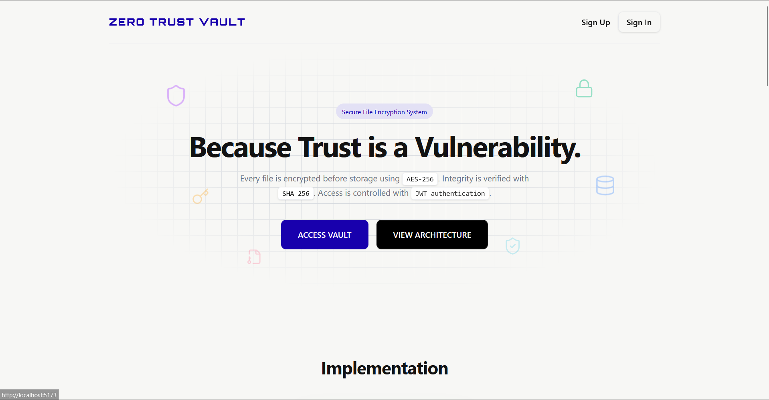
The landing page introduces the Zero-Trust Vault system with a minimal and secure design. It provides users with entry options to either access the vault or view system architecture. The interface is designed to reflect the core concept of security-first storage.
This screen does not interact with the database. It serves only as a static entry point and navigation layer to the authentication system.

Screen 2: User Registration Interface
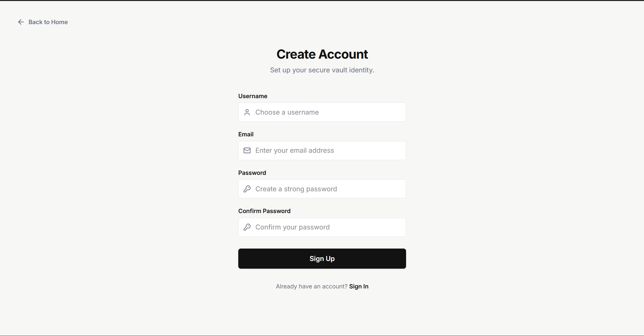
The registration interface allows new users to create an account using a username, email, and password. Input validation is applied on the client side to ensure basic format correctness before submission.
On the backend, user credentials are securely processed. Passwords are hashed using salted cryptographic hashing before being stored in the database. This ensures that plaintext passwords are never saved.

Screen 3: User Login Interface
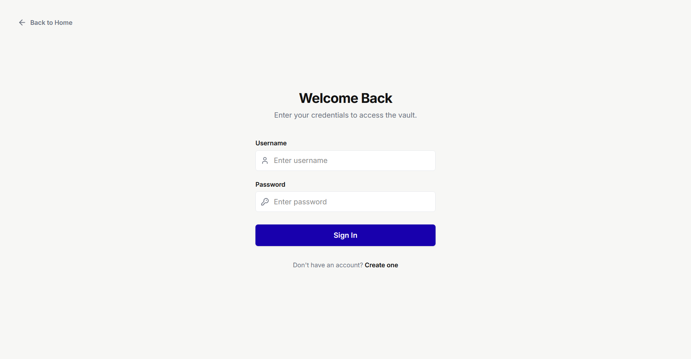
The login screen authenticates existing users using their registered credentials. If incorrect credentials are entered, a generic error message is displayed to prevent information disclosure.
During authentication, the server verifies the submitted password by comparing it with the stored salted hash. Upon successful validation, a JSON Web Token (JWT) is generated and returned to the client for session management.

Screen 4: Main User Dashboard
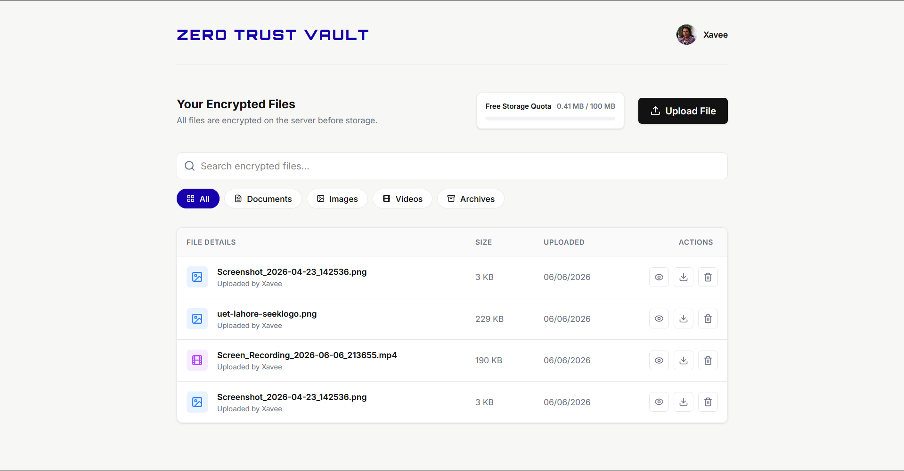
The dashboard is the central control panel of the system. It displays user information, uploaded files, and available storage usage. Users can upload, view, and download files from this interface.
The backend returns only file metadata to the dashboard. The actual encrypted file data remains stored securely in the database and is not directly exposed to the client.

Screen 5: File Upload and Encryption Process
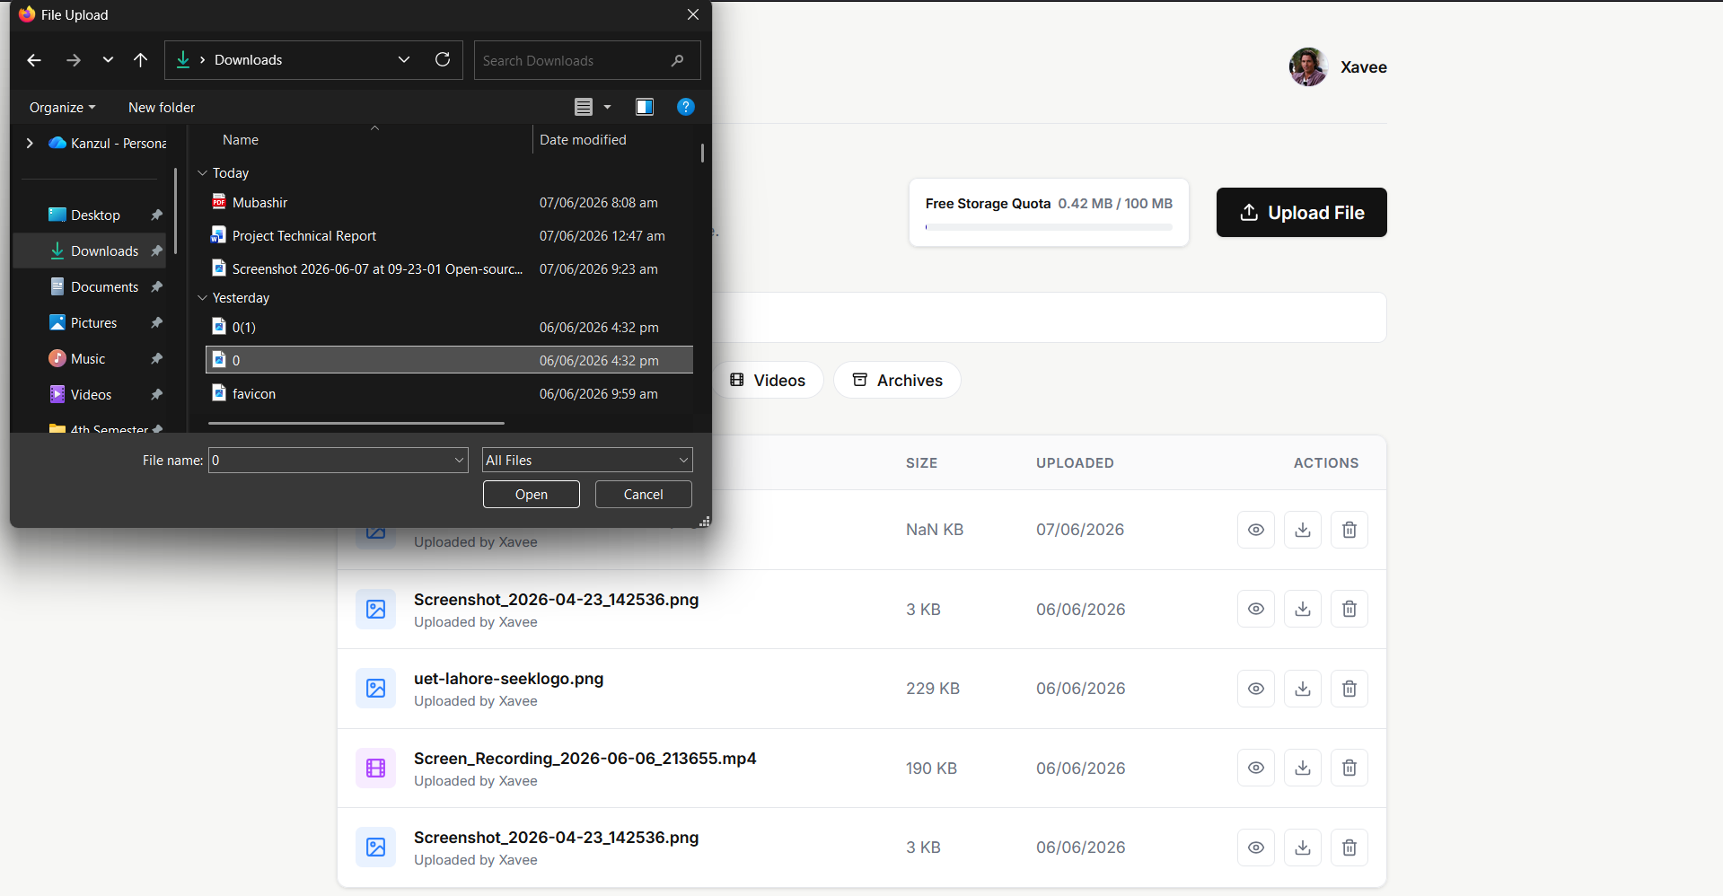
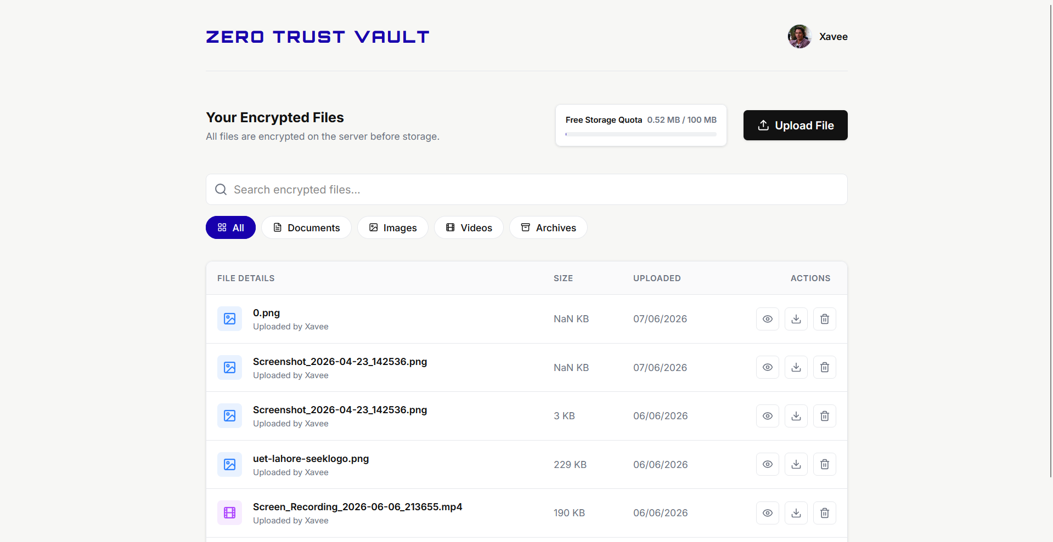

This screen allows users to upload files into the vault using drag-and-drop or file selection. After upload, the file is processed by the backend before storage.
The system encrypts the file using AES-256 encryption before saving it to the database. A SHA-256 hash is also generated to support integrity verification in later stages.

Screen 6: File Download and Decryption Process
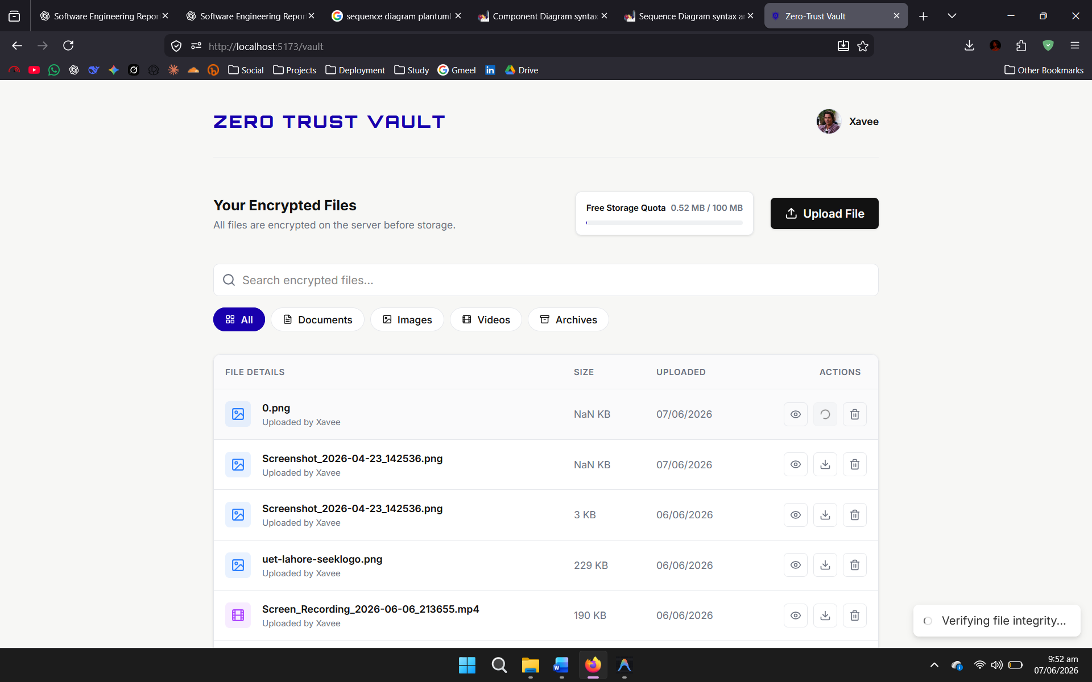
The download interface enables users to retrieve their stored files securely. Each file entry includes a download option that initiates the retrieval process.
When a file is requested, the server decrypts the encrypted data in a controlled environment and streams it directly to the client. The plaintext file is not permanently stored on the server.

Screen 7: Integrity Verification and Tamper Detection
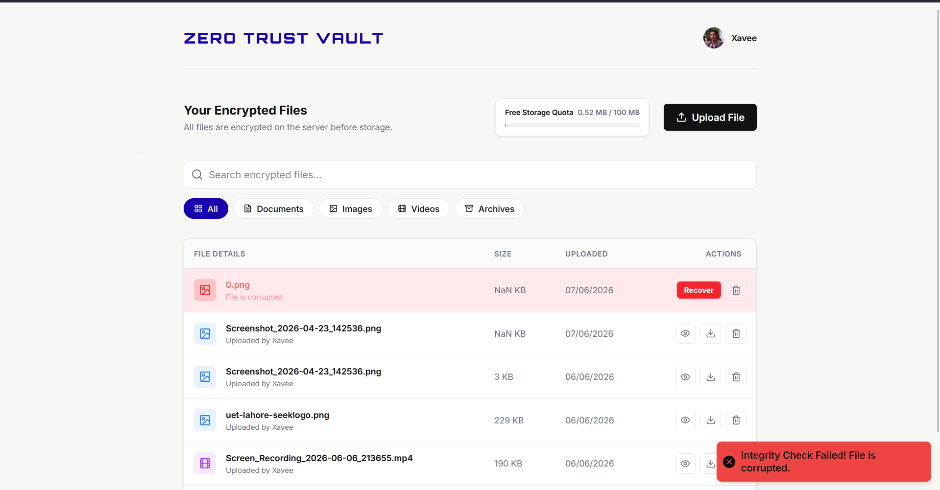
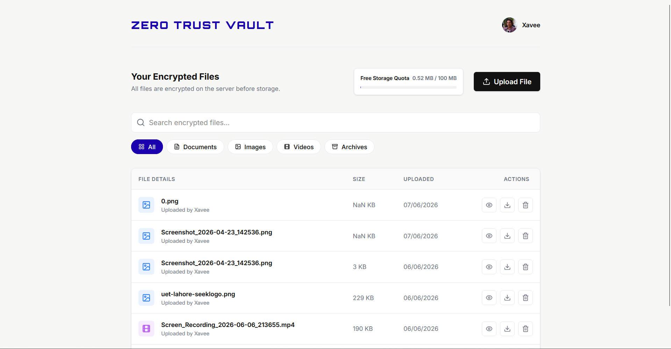
This screen shows the system’s response when file integrity verification is triggered. If any unauthorized modification or corruption is detected, the system marks the file as compromised.
The integrity check is performed using SHA-256 hash comparison. If the computed hash does not match the stored value, access to the file is restricted and recovery options may be enabled.

Testing and evaluation
This section presents the functional and security testing performed on the Zero-Trust Vault.

Security and Functional Test Cases
Test Case 1: Password Hashing and Authentication
Field | Details
Test Case | Password Hashing and Authentication
Objective | Verify secure storage and validation of user passwords
Test Steps | - Register user with password P@ssword123  - Check MongoDB stored data Login with correct password  - Login with incorrect password
Expected Result | Password stored as salted hash; correct login returns JWT; wrong password rejected
Actual Result | Password stored securely; authentication works correctly
Status | Pass

Test Case 2: File Encryption and Confidentiality at Rest
Field | Details
Test Case | File Encryption at Rest
Objective | Ensure files are stored in encrypted form
Test Steps | - Upload sensitive file  - Inspect MongoDB fileData
Expected Result | Only encrypted binary data should be stored
Actual Result | Data stored as encrypted buffer (not readable)
Status | Pass

Test Case 3: Integrity Verification and Tamper Detection
Field | Details
Test Case | File Integrity Verification
Objective | Detect unauthorized modification of files
Test Steps | - Modify file data in MongoDB.  - Try downloading file
Expected Result | Hash mismatch should block access
Actual Result | System detected tampering and blocked file
Status | Pass

Test Case 4: Backup Recovery Mechanism
Field | Details
Test Case | Self-Healing Recovery
Objective | Restore corrupted file from backup
Test Steps | - Corrupt file  - Click restore  - Download file
Expected Result | File restored from backup successfully
Actual Result | File restored and verified successfully
Status | Pass

Performance and Resource Evaluation
File Size | Encryption Time | Hashing Time | Decryption Time
100 KB | 12 ms | 4 ms | 8 ms
1 MB | 28 ms | 9 ms | 18 ms
5 MB | 78 ms | 24 ms | 52 ms
10 MB | 142 ms | 46 ms | 110 ms
15 MB | 210 ms | 68 ms | 165 ms
The system shows linear performance scaling with file size. Cryptographic processing introduces minor overhead, but remains acceptable for small to medium files. Streaming-based decryption ensures low memory usage by avoiding full file loading into RAM.
File size is restricted to 15MB due to database storage constraints and performance considerations.

Requirements Validation
Requirement | Objective | Verification Method | Status
Confidentiality | Protect stored files from unauthorized access | Encrypted storage verified in database | Verified
Integrity | Detect file modification or corruption | SHA-256 hash comparison | Verified
Availability | Ensure recovery of corrupted files | Backup restoration testing | Verified
Authentication | Secure login and session control | JWT authorization testing | Verified

Security recommendations
While the current prototype of the Zero-Trust Vault provides strong security at rest and in transit, transitioning the system into a production-grade environment requires additional hardening. The following improvements are recommended for stronger resilience against real-world threats.

Enterprise Key Management Service (KMS)
The current system uses a static encryption key stored in environment variables. If the server is compromised, the key may be exposed, leading to full data decryption risk.
Recommendation:
Adopt an external Key Management Service (KMS) such as AWS KMS, Azure Key Vault, or HashiCorp Vault. Encryption keys should be managed externally and accessed through secure authenticated APIs. Hardware Security Modules (HSMs) can further strengthen key protection.

Multi-Factor Authentication (MFA)
JWT authentication protects session access, but compromised credentials can still expose user accounts.
Recommendation:
Implement Time-Based One-Time Password (TOTP) authentication using applications such as Google Authenticator or Authy. This ensures login requires both password and temporary verification code.

API Rate Limiting and Intrusion Detection
Authentication and file endpoints are vulnerable to brute-force and automated attacks.
Recommendation:
Use rate-limiting middleware (e.g., express-rate-limit) to restrict repeated requests per IP address. Additionally, integrate intrusion detection tools such as Fail2Ban to block suspicious traffic patterns.

Immutable Audit Logging
System activity logs must be protected from modification for security compliance and forensic analysis.
Recommendation:
Implement a write-once audit logging system where all actions (upload, download, verification, recovery) are recorded in an isolated or cryptographically signed log store. This ensures tamper-proof auditing.

Ethical and legal considerations
Cryptographically secure storage systems introduce significant ethical and legal responsibilities, especially regarding user privacy and data control.

User Privacy and Data Protection (GDPR / CCPA)
Under global data protection laws, users have rights over their stored data.
- Users must be able to request complete data deletion (“Right to be Forgotten”).
- Deletion must remove both active files and backup copies.
- The system must only collect minimal required user data (username, email, password).

10.2 Responsible Data Handling
Since decryption occurs on the server, plaintext data exists temporarily in memory during processing.
Ethical Requirements:
- No logs or monitoring tools should capture decrypted buffers.
- Access to user files must be strictly controlled and auditable.
- Administrative access should be limited to prevent misuse of sensitive data.

Limitations
Despite strong security design, the current system has architectural limitations that restrict scalability and enterprise deployment.

Process Spawning Overhead
The system relies on spawning OpenSSL subprocesses for encryption and decryption. This introduces CPU overhead and limits high-concurrency performance.

MongoDB Document Size Limit
MongoDB enforces a 16MB limit per document. As a result, file uploads are restricted to approximately 15MB when stored as binary buffers.

Lack of Distributed Storage
The system stores files inside MongoDB instead of a dedicated object storage system. This limits scalability and increases database load.

Single Encryption Key Risk
A single master encryption key protects all files. If this key is compromised or lost, all stored data becomes unrecoverable

Conclusion

Objectives Achieved
- Confidentiality ensured through AES-256 encryption of stored files
- Integrity verified using SHA-256 hashing and tamper detection
- Availability supported through backup-based recovery system
- Zero plaintext persistence achieved through stream-based processing

Lessons Learned
The project provided practical understanding of cryptographic workflows, including key derivation, block cipher modes, secure hashing, and stateless authentication using JWT. It also demonstrated how system-level tools can be integrated into web architectures.

Future Enhancements
Future improvements include migration to native cryptographic libraries, implementation of client-side encryption using Web Crypto API, and integration with scalable cloud object storage systems.

References
- Rescorla, E. (2001). SSL and TLS: Designing and Building Secure Systems. Addison-Wesley.
- Chodorow, K. (2013). MongoDB: The Definitive Guide. O’Reilly Media.
- Node.js Documentation (2026). https://nodejs.org/api/
- OpenSSL Documentation (2026). https://www.openssl.org/docs/
- OWASP Cryptographic Storage Cheat Sheet (2026). https://cheatsheetseries.owasp.org/

